## PROGRAM DEFINITION

|  |
| --- |
|  |
| * This program is used to Soft Close Tax |

## RELATED TABLES

|  |  |
| --- | --- |
|  | **Access** |
| * PMT_TRANS_HD * TXT_TAX | R  RW |

## RELATED PROGRAMS

|  |  |
| --- | --- |
|  | **Access** |
|  |  |

## ROLES

|  |  |
| --- | --- |
|  | **Test** |
|  |  |

## INITIAL PROCESS

|  |  |
| --- | --- |
|  | **Test** |
|  |  |

## USER INTERFACE

**[CR02]**

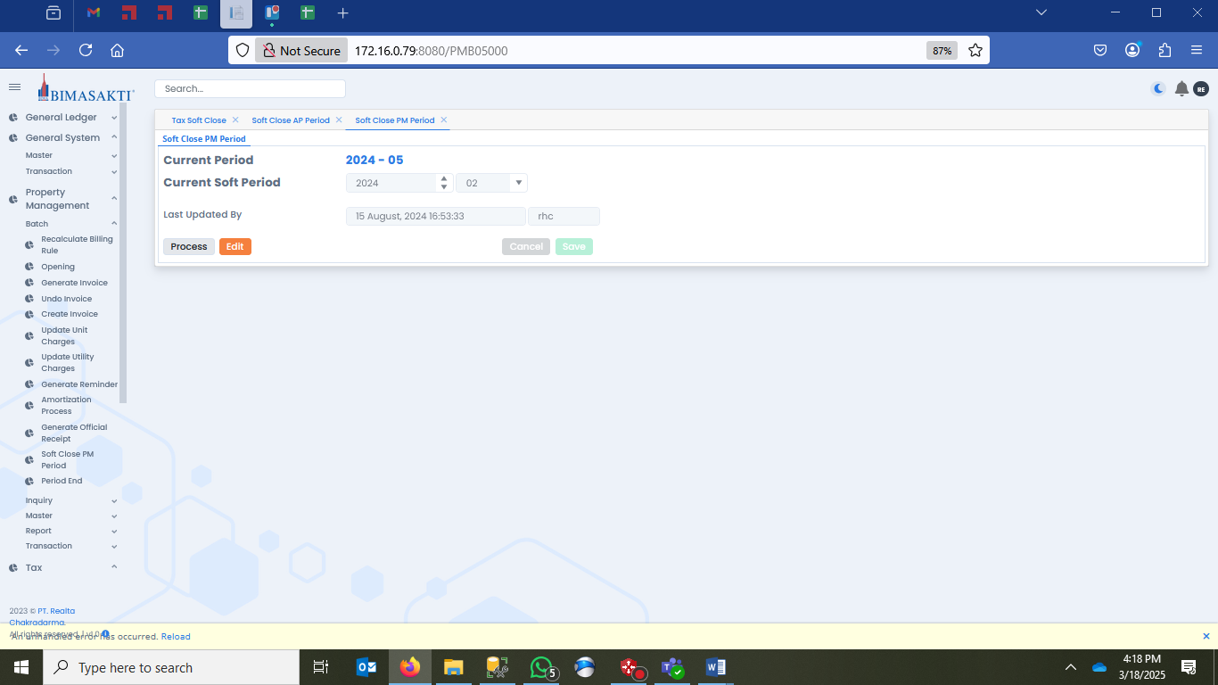



## BUTTON DEFINITION

|  |  |
| --- | --- |
|  | **Test** |
| * Button "Process" |  |

## DISPLAY PROCESS

|  |  |
| --- | --- |
|  | **Test** |
| * **[CR02]**   EXEC RSP_TX_GET_SOFT_CLOSE_PERIOD ‘Login Company Id’, ‘Login User Id’   * Display data [PARAMETER]:   + "Property"     - Combobox     - Display = CPROPERTY_NAME     - Field = CPROPERTY_ID     - Value = EXEC RSP_GS_GET_PROPERTY_LIST [Login CCOMPANY_ID]   **[CR02]**   * + "Current Period"     - Label     - Display = CSOFT_CLOSE_PRD   + "Period"     - Year       * Numeric Spinner       * Display = CPERIOD_YEAR       * **[CR01]** Default Value = EXEC RSP_GS_GET_TAX_NEXT_PERIOD [Login CCOMPANY_ID], ‘S’     - Month       * Combobox       * Display = CPERIOD_MONTH   **[CR01]**   * + - * Default Value = EXEC RSP_GS_GET_TAX_NEXT_PERIOD [Login CCOMPANY_ID] , ‘S’       * Value = ~~EXEC RSP_GS_GET_PERIOD_DT_LIST [Login CCOMPANY_ID], [Selected Year]~~       * EXEC RSP_TX_GET_PERIOD_DT_LIST [Login CCOMPANY_ID], [Selected Year], ‘S’   **[CR02]**   * + "Last Closed By"     - Textbox     - Display = DSOFT_CLOSING_DATE, CSOFT_CLOSING_BY |  |
| * Proses   + - * + "Process" 🡪 Go to Process |  |

## MODIFY

|  |  |
| --- | --- |
|  | **Test** |
| * Modify Process, jalankan SP berikut:   EXEC RSP_TX_MAINTAIN_SOFT_CLOSE  "Login Company Id"  , Period "Year"  , Period "Month"  , CACTION = ‘EDIT’  , Login User Id |  |
| * Go to DISPLAY PROCESS |  |

## PROCESS

|  |  |
| --- | --- |
|  | **Test** |
| * ~~Jalankan RSP_TX_VALIDATE_SOFT_CLOSE_TAX dengan parameter, simpan hasil ke VAR_VALIDATE_RESULT~~   ~~"Login Company Id"~~  ~~, "Property" Id~~  ~~, Period "Year"~~  ~~, Period "Month"~~  ~~, Login User Id~~   * ~~IF VAR_VALIDATE_RESULT NOT EMPTY~~   + ~~Jalankan POPUP TO DO LIST dengan VAR_VALIDATE_RESULT~~   ~~ELSE~~   * ~~Soft Close Process, jalankan SP berikut:~~   ~~EXEC RSP_TX_SOFT_CLOSE_TAX~~  ~~"Login Company Id"~~  ~~, "Property" Id~~  ~~, Period "Year"~~  ~~, Period "Month"~~  ~~, Login User Id~~   * **~~[CR01]~~** ~~Jika tidak ada error, tampilkan message "Soft Close Tax Successfully", OK~~   **[CR02]**   * Jalankan RSP_TX_VALIDATE_SOFTCLOSE_PRD dengan parameter, simpan hasil ke VAR_VALIDATE_RESULT   "Login Company Id"  , Period "Year"  , Period "Month"  , Login User Id   * IF VAR_VALIDATE_RESULT NOT EMPTY   + Jalankan POPUP TO DO LIST dengan VAR_VALIDATE_RESULT   ELSE   * + Jalankan RSP_TX_SOFT_CLOSE_TAX dengan parameter, simpan hasil ke VAR_RESULT   "Login Company Id"  , Period "Year"  , Period "Month"  , Login User Id  IF Error   * + Display Error Message   ELSE   * + Display message ‘Soft Closing processed successfully!’   + Back to Display Process   **[CR02/]** |  |
| * Go to DISPLAY PROCESS |  |



### Error Process

|  |  |
| --- | --- |
| **[CR02]** | **Test** |
| * Display error data [PARAMETER]:   + "No."     - Label     - Display = ISEQ_NO   + "Dept"     - Label     - Display = CDEPT_NAME   + "Transaction Type"     - Label     - Display = CTRANS_DESCR   + "Module"     - Label     - Display = CMODULE_ID   + "Reference No."     - Label     - Display = CREF_NO   + "Reference Date"     - Label     - Display = CREF_DATE   + "Status"     - Label     - Display = CTRANS_STATUS_DESCR   + "Description"     - Label     - Display = CDESCRIPTION   + "Solution"     - Label     - Display = CSOLUTION_DESCR |  |
| * Save to Excel   + - * + "Save to Excel" 🡪 Save list into file Excel with format file SOFT_CLOSE_TX_CurrentSoftPeriod_ERROR_LIST |  |

## ERROR CODE / WARNING MESSAGE DEFINITION

|  |  |
| --- | --- |
| **Error Code / Warning Message** | **Error Message** |
|  |  |
|  |  |

# CR LIST

|  |  |  |
| --- | --- | --- |
| **CR** | **Description** | **Notes** |
| **CR01**  **RE, 15 August 2024** | * Menambahkan notifkasi saat process selesai |  |
| **CR02**  **RE, 18 Mar 2025** | * Mengubah UX process sama dengan soft process lainnya |  |